User Guide – Purchasing Application, Psychology Portal
To Create an Order:
- Navigate to https://My.psychology.illinois.edu
- Log in using your university credentials….
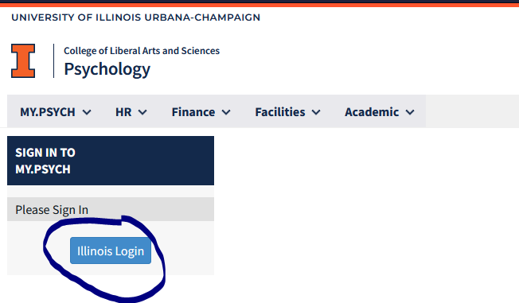
- Choose “Purchasing” from the “Finance” dropdown…
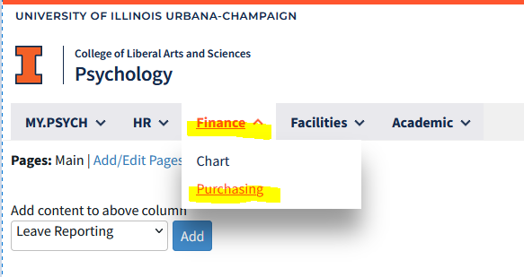
- Click the “Create Order” button in the “Action” section…
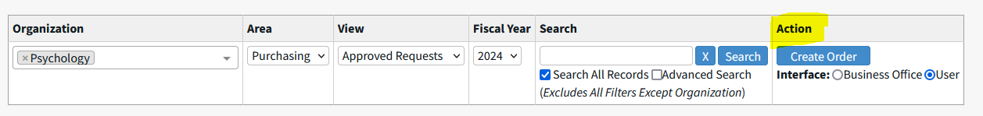

- Enter your personal/requestor information….
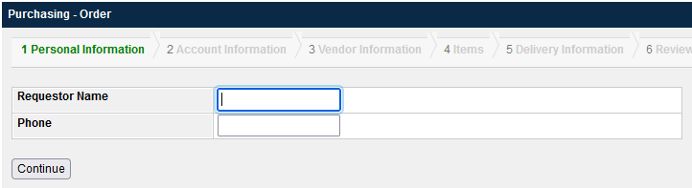
- Click on “View My Accounts” to find CFOP’s/account numbers associated with you, or manually type in the CFOP you’d like to use in the blank fields (“activity” is an optional field). If you’re splitting the expense between two CFOP’s, you may indicate that by using the “Split” field. The app will continue to generate blank CFOP lines so that you can continue to add as many accounts as necessary. (In the example below, I’m using two CFOP’s and splitting the expenses 50/50 between the two. I will be able to click “Continue” even though there are blank fields on the screen.) Also indicate if this purchase will contain items used to fabricate equipment by clicking the appropriate radial button (yes or no), then click continue.
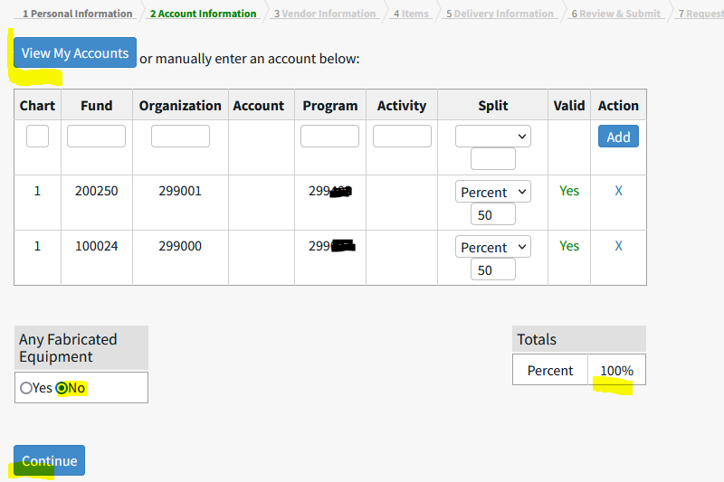
- Indicate your vendor by either choosing from the department pre-loaded list (all are confirmed vendors in Banner) or enter the vendor manually. You don’t need to enter the exact address – just provide us with what you have (a link, name, etc.). If you choose a vendor from the dept. list, it’s ok to choose “Address Unknown”.
**Please note: only one vendor should be indicated for each portal order. You can have multiple items from one vendor on a single order, but not multiple vendors. This is because each order is reconciled to a single Banner (system of record) transaction. Those transactions are separated by vendor because of the different vendor ID’s, billing, invoicing processes, etc. Thank you!**
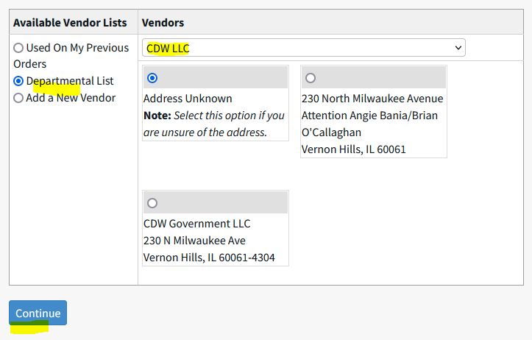
- Enter the information you have for the item you’re requesting – the more info the better. If you received a quote from a vendor, please upload it on this page (not a requirement on all orders – the procurement team can advise. Please send inquiries to psych-purchasing@mx.uillinois.edu if you have questions). Click the “Add” button when you’ve finished entering your item details. If what you’re purchasing isn’t a deliverable (e.g. Facebook ads), click the “No Delivery Expected” button. Keep adding items until you’ve completed your order. When all items have been added to your order, please hit “Continue” ….
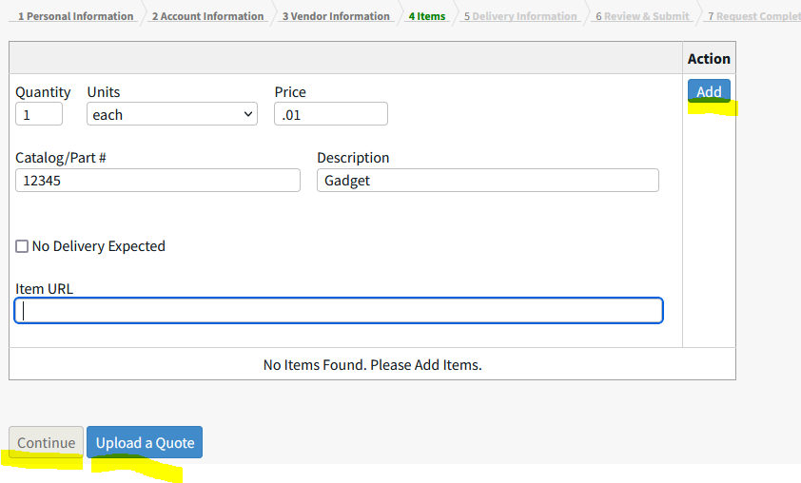
- Enter your delivery information if applicable – if the desired dept/address isn’t available in the dropdown list, please check the “other” box and manually enter the delivery address (items cannot be shipped to home addresses). The delivery address for the Psych Bldg. is indicated in the example below…
- Please also indicate your desired shipping method and the procurement team will request expedited shipping for you as requested – with the understanding that expedited shipping may incur extra charges. Please note that although you’re allowed to enter a “required by” date, we cannot guarantee that the vendor will have the item in stock and that they can get it to us by your desired date – we’ll do our best!
- If someone else is authorized to pick up/receive your order, indicate that in the “Pickup Proxies” section.
- Please enter any comments or special instructions – Example: you might use this area to indicate that although you entered your PRO/ICR CFOP, you’d actually like to use your annual professional development funding.
- Click continue when you’re finished.
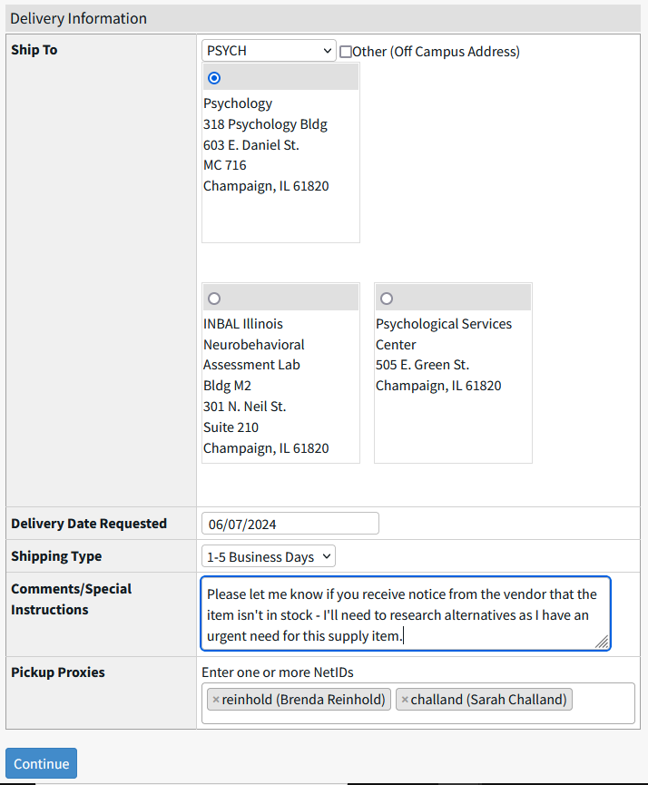
- Review your order, scroll to the bottom of the page, and enter the business purpose of the purchase. This is especially important for grant-funded purchases. Enter the who, what, where, why/how it benefits the university/research/instruction/other primary mission of the institution. 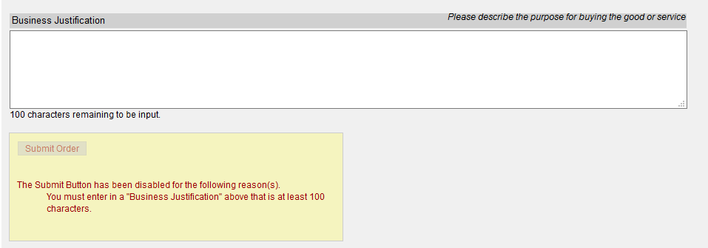

- Click “Submit Order” if everything looks correct. You may click “Revisit” in any sections to edit/add to the order. If your justification doesn’t meet the 100 character minimum requirement, just enter special characters to complete the field. This minimum is set by Engineering (developers of the app) for all departments on campus that use this purchasing module, and it can’t be adjusted by individual unit.
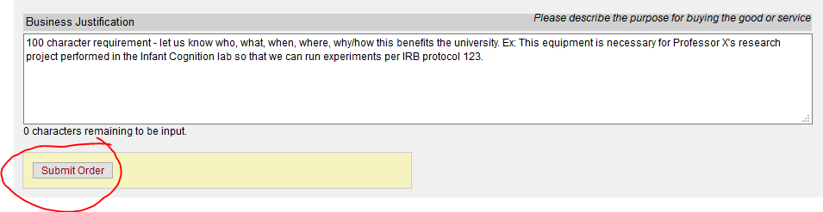
- You will receive the following message…
