The department-paid Copy Room Services are reserved for instructional and administrative printing needs due to budget constraints.


If you have research printing that you need to have done, please use one of the following options:

- Work with Psych-help@illinois.edu (Psych IT Team: Fred Beuttler and Firmino Pinto) to get recommendations for a lab printer. Orders for printers, toner, and copy paper for research needs can be submitted through the purchasing app.

- For large format posters, web printing from laptops, etc., Technology Services Printing may be a good choice.
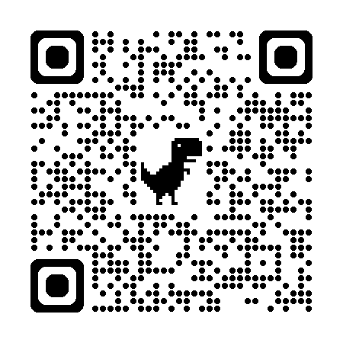

- Beckman Printing also provides poster printing services.
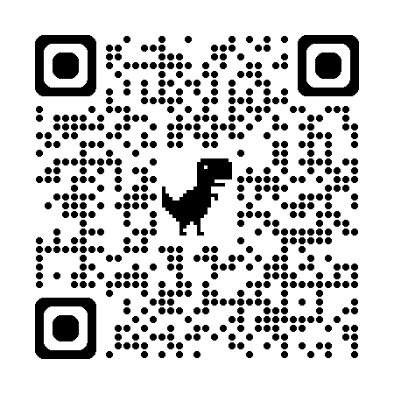
- Document Services at the Illini Union offers many options for printing. You may submit your order online via their printing order form or you can email them with your order and a copy of the file you wish to have printed (Dropbox can be used to send large files). Document Services provides complimentary pickup and delivery to campus offices for orders that are paid for with a CFOP/university account.
