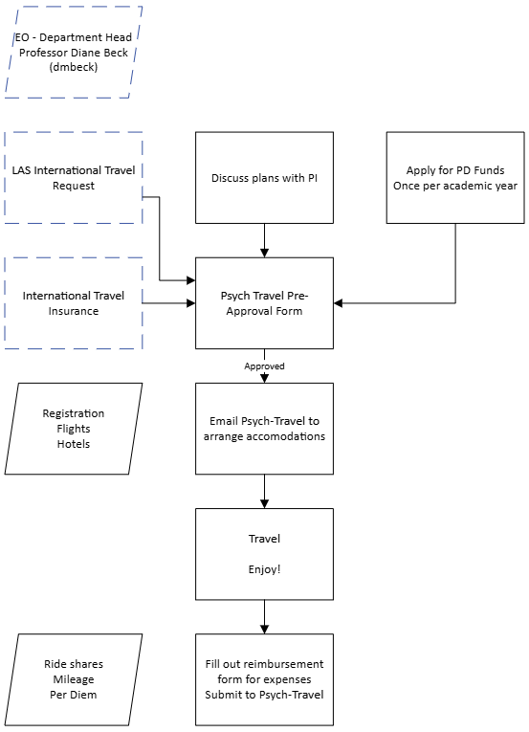

**Note:** Please plan ahead as approvals at each step may take up to a week to process

Fill out Travel Pre-Approval Form

* You will need:
  + Details of the travel - including business purpose
    - Presenting research counts as the business purpose
  + Funding sources
    - Professional Development Funds are available per academic year
      * Students need apply - faculty do not need apply
    - Funds from faculty members need the CFOP (University funding account) **number** and dollar amount they will cover
  + LAS International Travel Request*
  + International Travel Insurance* - MANDATORY
    - *International travel only

Contact Business Office to arrange travel

* Things the Business Office can pay on your behalf
  + Flights or scheduled trains/buses
  + Hotels
  + Registration/Membership Fees
* Funding must be on-record for anything the Business Office purchases for you
  + Business Office will not book anything over the amount of funds committed already

Complete your trip

Submit Travel Reimbursement Form for expenses on trip

* Ride shares (need the to and from for each)
* Mileage if driving to location
* Per diem**

**Per diem

* Business Office needs:
  + Start Date and time (closest 30 minutes - e.g. 10:30 am)
  + End Date and time (closest 30 minutes - e.g. 9:30 pm)
  + Any meals covered by conference/other (e.g. 2/15 lunch and dinner)

Summary

Fill Out:

* Before Travel
  + Pre-Approval Form
  + (LAS International Form)
  + (International Insurance)
* After Travel
  + Travel Reimbursement Form

Turn In:

* Receipts for registration costs
* Flight confirmations
* Hotel folio (itemized receipt from hotel received at check-out)
* Receipts for ride shares/trains/etc.
* Receipts for baggage/parking